**Business Intelligence Guidebook**

**Templates**

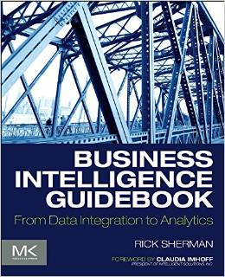

**Chapter 10:**

**BI Dimension Model - Detailed Design Template**



[Company Name]

BI Dimension Logical Model –

Detailed Design Template

[Project Name]

Date: [Select Date]

Author(s):

Sponsor(s):

Table of Contents

BI Dimensional Logical Model Design 4

DATA STORE: [NAME] 4

• COLUMNS 5

• CONSTRAINTS 6

• INDEXES 7

• DATA STORE LOGICAL MODEL 8

Approvals 10

Appendix: Background Materials 11

Authors and contributors 11

|  |  |
| --- | --- |
|  | The content of the template is what is important rather than how is presented or formatted. If the project uses a data modeling tool then the contents of this document may be created and managed in that tool.  **Note: to delete any tip, such this one, just click the tip text and then press the spacebar.** |

# BI Dimensional Logical Model Design

|  |  |
| --- | --- |
|  | See Chapter 9 “Dimensional Modeling” and Chapter 10 “BI Dimensional Modeling” of the BI Guidebook for a discussion on the purpose and design of a BI dimensional model. A logical dimensional model should be created for each data store within the BI data architecture. The physical model will be dependent on the technology used to implement a data store. |

## DATA STORE: [NAME]

|  |  |
| --- | --- |
|  | The detailed design for a data store follows. Repeat this section for each. |

Data Store:

Schema Type:

Description:

Status:

Last Updated:

Person Responsible for Design:

Supporting team (if applicable):

### COLUMNS

|  |  |
| --- | --- |
|  | List and describe the columns for each entity. |

Table 1: Table (or Views) & Columns

|  |  |  |  |  |  |  |
| --- | --- | --- | --- | --- | --- | --- |
| Table | Column | Key Type | Data Type | Is Nullable | Default Value | Description |
|  |  |  |  |  |  |  |
|  |  |  |  |  |  |  |
|  |  |  |  |  |  |  |
|  |  |  |  |  |  |  |
|  |  |  |  |  |  |  |
|  |  |  |  |  |  |  |
|  |  |  |  |  |  |  |
|  |  |  |  |  |  |  |
|  |  |  |  |  |  |  |
|  |  |  |  |  |  |  |

### CONSTRAINTS

|  |  |
| --- | --- |
|  | List and describe the constraints for each entity. |

Table 2: Constraints

|  |  |  |  |  |
| --- | --- | --- | --- | --- |
| Constraint  Name | Constraint  Type | Table | Column | Description |
|  |  |  |  |  |
|  |  |  |  |  |
|  |  |  |  |  |
|  |  |  |  |  |
|  |  |  |  |  |
|  |  |  |  |  |
|  |  |  |  |  |
|  |  |  |  |  |
|  |  |  |  |  |
|  |  |  |  |  |

### INDEXES

|  |  |
| --- | --- |
|  | List and describe the indexes that are identified during the logical design. |

|  |  |
| --- | --- |
|  | Further indexes or modifications will occur during physical design, load testing and monitoring ongoing usage.  There may be specific technologies such as columnar or OLAP databases, for example, that eliminate the need for creating indexes. |

Table 3: Indexes

|  |  |  |  |  |
| --- | --- | --- | --- | --- |
| Index Name | Index Type | Table | Column | Description |
|  |  |  |  |  |
|  |  |  |  |  |
|  |  |  |  |  |
|  |  |  |  |  |
|  |  |  |  |  |

### DATA STORE LOGICAL MODEL

|  |  |
| --- | --- |
|  | For each data store provide a logical data model with entities, relationships and attributes. |

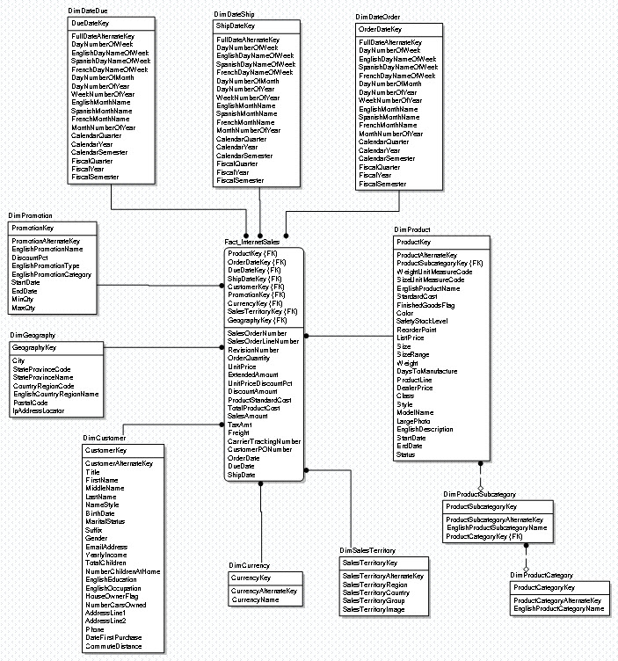

Figure 1: Example of a Data Store's Logical Data Model

|  |  |
| --- | --- |
|  | For illustration purposes the diagrams in this template use a modified version of sample databases provided by Microsoft’s Adventure Works. These samples support learning BI concepts in conjunction with SQL Server and associated products, but from the logical modeling perspective are vendor agnostic.  You can examine the latest samples in CodePlex, TechNet or MSDN. |

# Approvals

|  |  |
| --- | --- |
|  | It is a best practice to obtain sign-off approval of each project milestone. An organization’s policies and culture will dictate who the approvers will be, but typically the sponsors and key stakeholders are included. |

|  |  |  |
| --- | --- | --- |
| Title | Name | Approval  Date |
|  |  |  |
|  |  |  |
|  |  |  |
|  |  |  |
|  |  |  |

# Appendix: Background Materials

|  |  |
| --- | --- |
|  | This section includes all background or supporting materials for the BI Milestone Plan These materials may include:   * The milestone plan assumptions such as resources, funding, etc. * A more detailed project plan if defined |

## Authors and contributors

|  |  |
| --- | --- |
|  | List all the people involved in obtaining and analyzing the requirements, along with the authors of this deliverable. |